Ryan Wandera
BSCCS/2024/34339
Mount Kenya University
Michael nNyoro
Ethical Hacking and Counter Measures

Task 1: Website vulnerability testing 8
Tool Specification 8
Screenshots 8
ZAP by Checkmarx Scanning Report 13
Organization Information 27
Target System 31
Week 6 36
Practical Task 1 36
Basic Vulnerability Scan 36
SCAN REPORT 36
1. Objective 36
2. Tools Used 36
3. Host Discovery 36
Command Used 36
Results 36
Observation 36
4. Port Scanning 36
Command Used 37
Results 37
Observation 37
5. Vulnerability Assessment Findings 37
Finding 1: SSH Service Expose 37
Finding 2: Web Server Running 37
Finding 3: Multiple Services Running 37
6. Summary of Observations 37
7. Recommendations 37
Practical Task 2 38
Vulnerability Research Assignment 38
Vulnerability Research Assignment 38
1. CVE-2024-3400 39
Description 39
Severity 39
Potential Impact 39
Mitigation Strategy 39
2. CVE-2024-3094 39
Description 39
Severity 39
Potential Impact 39
Mitigation Strategy 39
3. CVE-2024-4577 40
Description 40
Severity 40
Potential Impact 40
Mitigation Strateg 40
4. CVE-2024-6387 40
Description 40
Severity 40
Potential Impact 40
Mitigation Strateg 40
5. CVE-2024-21762 40
Description 40
Severity 41
Potential Impact 41
Mitigation Strategy 41
Practical Task 3 41
Organizational Vulnerability Assessment Plan 41
Organizational Vulnerability Assessment Plan 41
1. University Network 41
Scope 41
Tools 41
Schedule 41
Reporting Procedure 42
2. Small Business 42
Scope 42
Tools 42
Schedule 42
Reporting Procedure 42
3. Hospital 42
Scope 42
Tools 43
Schedule 43
Reporting Procedure 43
4. Financial Institution 43
Scope 43
Tool 43
Schedule 43
Reporting Procedure 44
Week 7 44
Web Application Security and OWASP 44
Practical Task 1 44
OWASP Top 10 Research 44
OWASP Top 10 Vulnerabilities Research 44
1. Broken Access Control 44
Definition 44
Example 44
Impact 44
Prevention 45
2. Cryptographic Failures 45
Definition 45
Example 45
Impact 45
Prevention 45
3. Injection 45
Definition 45
Example 45
Impact 45
Prevention 46
4. Insecure Design 46
Definition 46
Example 46
Impact 46
Prevention 46
5. Security Misconfiguration 46
Definition 46
Example 46
Impact 46
Prevention 47
6. Vulnerable and Outdated Components 47
Definition 47
Example 47
Impact 47
Prevention 47
7. Identification and Authentication Failures 47
Definition 47
Example 47
Impact 47
Prevention 48
8. Software and Data Integrity Failures 48
Definition 48
Example 48
Impact 48
Prevention 48
9. Security Logging and Monitoring Failures 48
Definition 48
Example 48
Impact 49
Prevention 49
10. Server-Side Request Forgery (SSRF) 49
Definition 49
Example 49
Impact 49
Prevention 49
Practical Task 2 49
Web Application Assessment 49
Target Application 50
1. Forms Identified 50
Login Form 50
Registration Form 50
Search Form 50
Feedback Form 50
Contact Form 50
2. Authentication Mechanisms 50
Username and Password Authentication 50
Session Management 51
Password Recovery 51
3. User Roles 51
Guest User 51
Registered User 51
Administrator 51
4. Potential Vulnerabilities 51
SQL Injection 51
Cross-Site Scripting (XSS) 52
Broken Access Control 52
Weak Authentication 52
Cross-Site Request Forgery (CSRF) 53
Security Misconfiguration 53
Practical Task 3 53
Security Improvement Proposal 53
Authentication Controls 53
Objective 53
Recommended Controls 54
3. Input Validation Measures 54
Objective 54
Recommended Measures 54
4. Logging Mechanisms 55
Objective 55
Recommended Mechanisms 55
Log Retention Policy 56
5. Patch Management Strategy 56
Objective 56
Recommended Strategy 56
6. Expected Benefits 56

Task 1: Website vulnerability testing

Tool Specification
Specification Details
Tool Name OWASP ZAP (Zed Attack Proxy)
Developer OWASP Foundation
License Open Source
Platform Windows, Linux, macOS
Language Java
Purpose Web Application Vulnerability Testing
Features Spidering, Passive Scanning, Active Scanning, Report Generation
GUI Support Yes

Screenshots
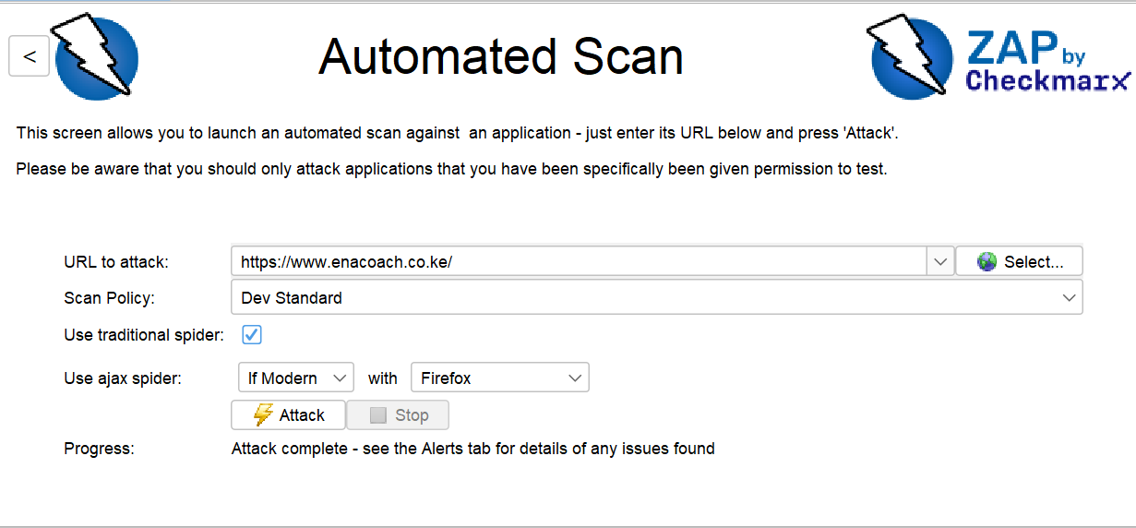

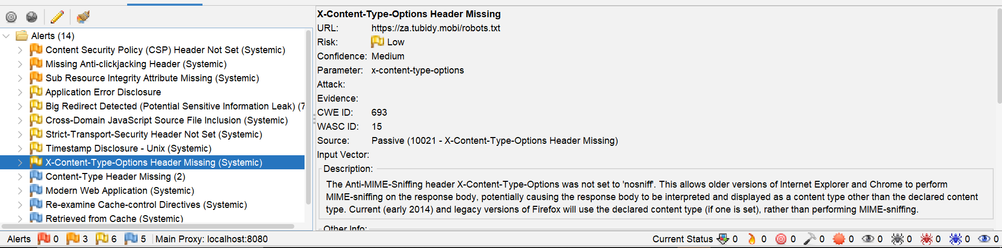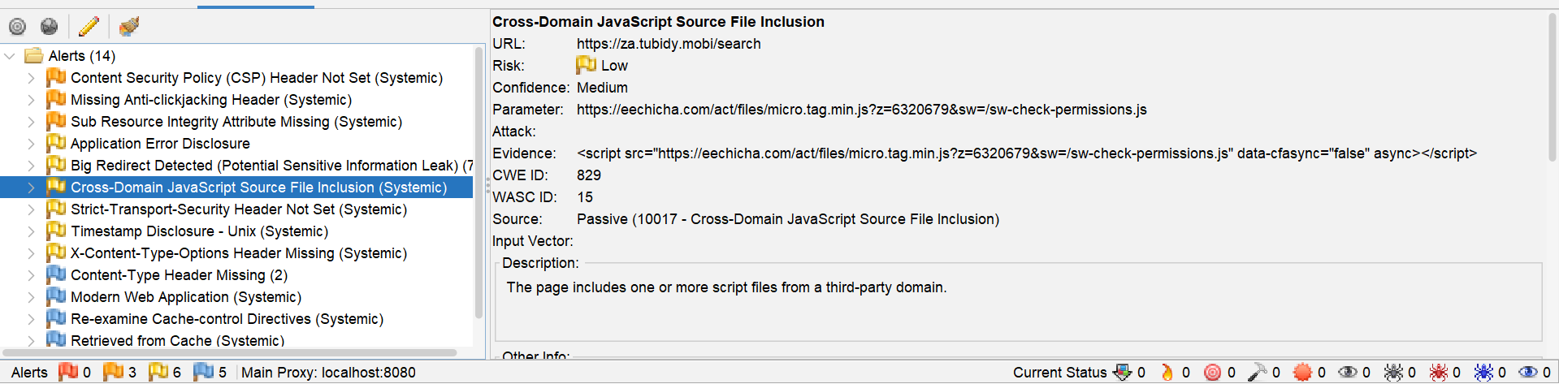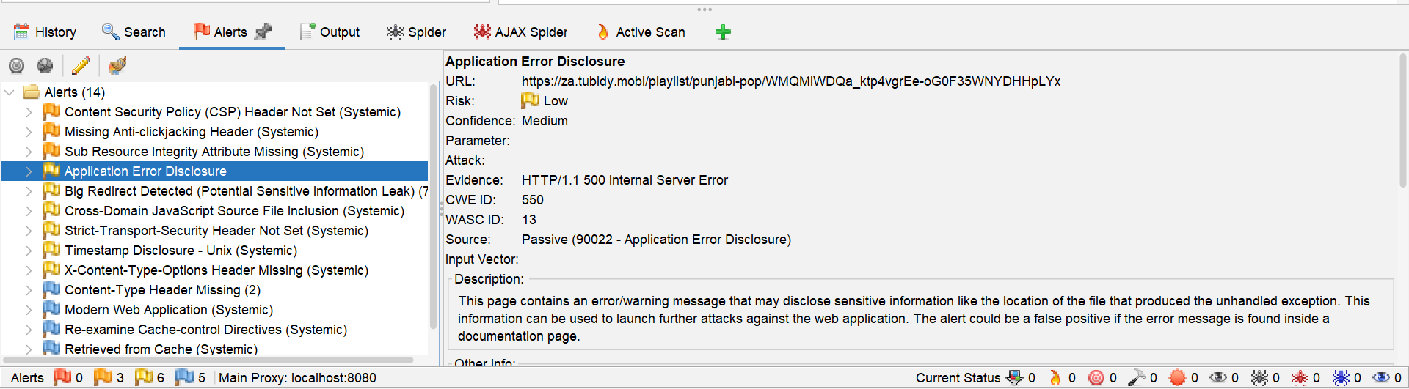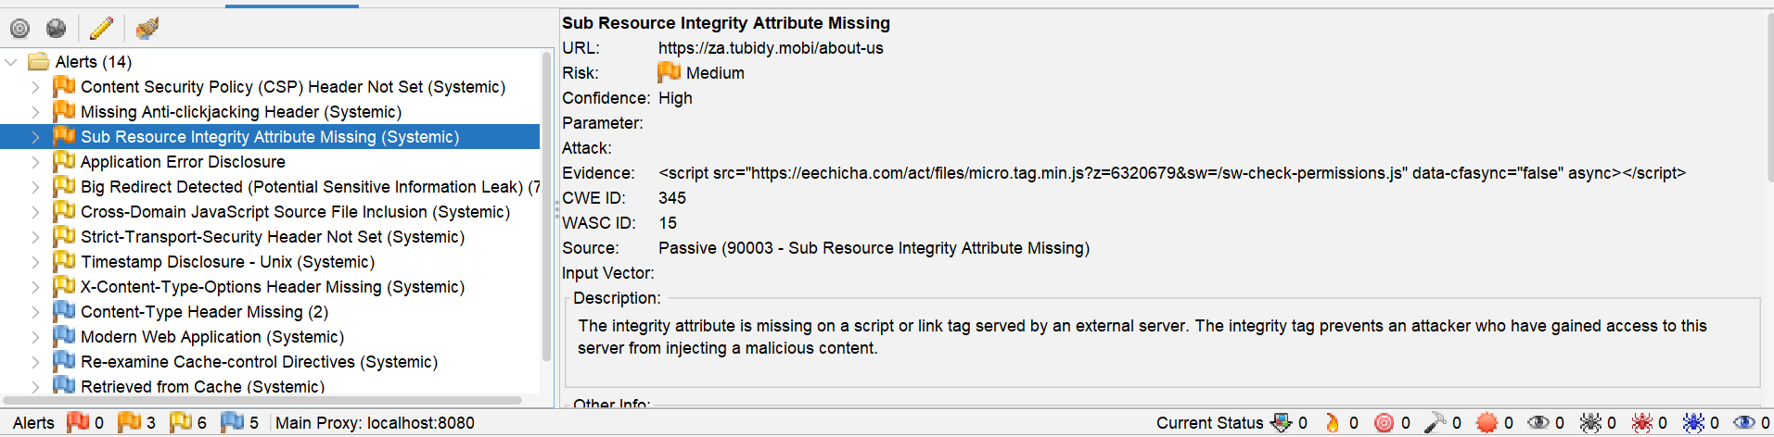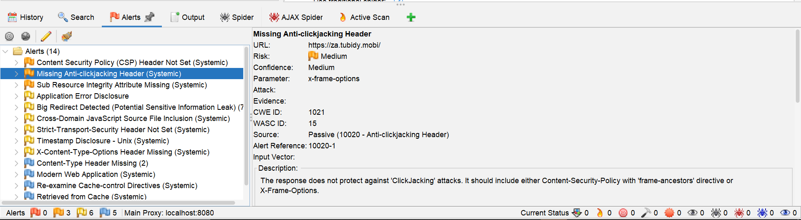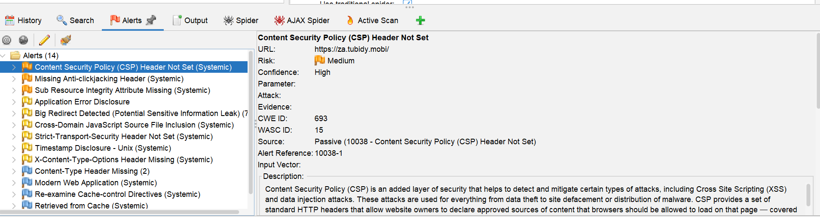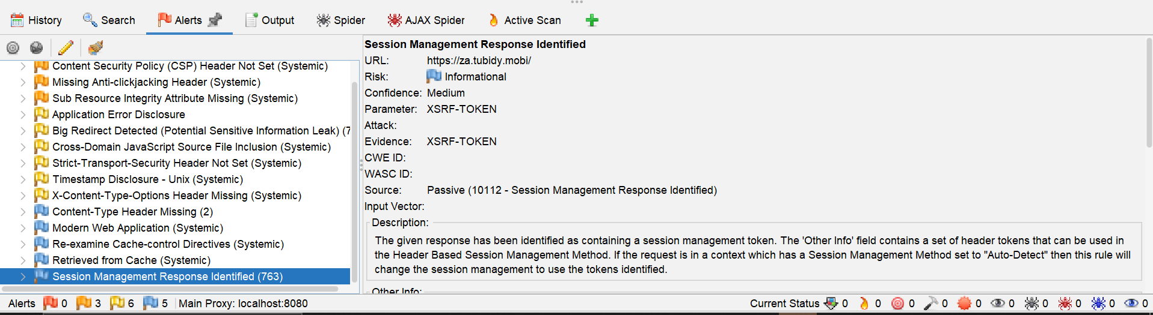

ZAP by Checkmarx Scanning Report
Generated with The ZAP logoZAP on Thu 11 Jun 2026, at 12:27:45

ZAP Version: 2.17.0

ZAP by Checkmarx

Contents
About This Report
Report Parameters
Summaries
Alert Counts by Risk and Confidence
Alert Counts by Site and Risk
Alert Counts by Alert Type
Insights
Alerts
Risk=Medium, Confidence=High (2)
Risk=Medium, Confidence=Medium (1)
Risk=Low, Confidence=High (1)
Risk=Low, Confidence=Medium (4)
Risk=Low, Confidence=Low (1)
Risk=Informational, Confidence=Medium (4)
Risk=Informational, Confidence=Low (1)
Appendix
Alert Types
About This Report
Report Parameters
Contexts
No contexts were selected, so all contexts were included by default.

Sites
The following sites were included:

https://www.enacoach.co.ke
https://za.tubidy.mobi
(If no sites were selected, all sites were included by default.)

An included site must also be within one of the included contexts for its data to be included in the report.

Risk levels
Included: High, Medium, Low, Informational

Excluded: None

Confidence levels
Included: User Confirmed, High, Medium, Low

Excluded: User Confirmed, High, Medium, Low, False Positive

Summaries
Alert Counts by Risk and Confidence
This table shows the number of alerts for each level of risk and confidence included in the report.

(The percentages in brackets represent the count as a percentage of the total number of alerts included in the report, rounded to one decimal place.)

Confidence
User Confirmed High Medium Low Total
Risk High 0
(0.0%) 0
(0.0%) 0
(0.0%) 0
(0.0%) 0
(0.0%)
Medium 0
(0.0%) 2
(14.3%) 1
(7.1%) 0
(0.0%) 3
(21.4%)
Low 0
(0.0%) 1
(7.1%) 4
(28.6%) 1
(7.1%) 6
(42.9%)
Informational 0
(0.0%) 0
(0.0%) 4
(28.6%) 1
(7.1%) 5
(35.7%)
Total 0
(0.0%) 3
(21.4%) 9
(64.3%) 2
(14.3%) 14
(100%)
Alert Counts by Site and Risk
This table shows, for each site for which one or more alerts were raised, the number of alerts raised at each risk level.

Alerts with a confidence level of "False Positive" have been excluded from these counts.

(The numbers in brackets are the number of alerts raised for the site at or above that risk level.)

Risk
High
(= High) Medium
(>= Medium) Low
(>= Low) Informational
(>= Informational)
Site https://www.enacoach.co.ke 0
(0) 0
(0) 0
(0) 1
(1)
https://za.tubidy.mobi 0
(0) 3
(3) 6
(9) 4
(13)
Alert Counts by Alert Type
This table shows the number of alerts of each alert type, together with the alert type's risk level.

(The percentages in brackets represent each count as a percentage, rounded to one decimal place, of the total number of alerts included in this report.)

Alert type Risk Count
Content Security Policy (CSP) Header Not Set Medium 8
(57.1%)
Missing Anti-clickjacking Header Medium 6
(42.9%)
Sub Resource Integrity Attribute Missing Medium 7
(50.0%)
Application Error Disclosure Low 1
(7.1%)
Big Redirect Detected (Potential Sensitive Information Leak) Low 7
(50.0%)
Cross-Domain JavaScript Source File Inclusion Low 5
(35.7%)
Strict-Transport-Security Header Not Set Low 10
(71.4%)
Timestamp Disclosure - Unix Low 5
(35.7%)
X-Content-Type-Options Header Missing Low 10
(71.4%)
Content-Type Header Missing Informational 2
(14.3%)
Modern Web Application Informational 6
(42.9%)
Re-examine Cache-control Directives Informational 6
(42.9%)
Retrieved from Cache Informational 5
(35.7%)
Session Management Response Identified Informational 763
(5,450.0%)
Total 14
Insights
This table shows information that is likely to be very relevant to you, but which is not related to vulnerabilities, or potentially even related to the application in question.

Level Reason Site Description Statistic
Low
Warning
ZAP errors logged - see the zap.log file for details
19
Low
Warning
ZAP warnings logged - see the zap.log file for details
36,639
Info
Informational
Percentage of network failures
6 %
Info
Informational
https://www.enacoach.co.ke
Percentage of responses with status code 2xx
89 %
Info
Informational
https://www.enacoach.co.ke
Percentage of responses with status code 4xx
10 %
Info
Informational
https://www.enacoach.co.ke
Percentage of endpoints with content type application/javascript
57 %
Info
Informational
https://www.enacoach.co.ke
Percentage of endpoints with content type image/png
14 %
Info
Informational
https://www.enacoach.co.ke
Percentage of endpoints with content type text/css
4 %
Info
Informational
https://www.enacoach.co.ke
Percentage of endpoints with content type text/html
14 %
Info
Informational
https://www.enacoach.co.ke
Percentage of endpoints with method GET
100 %
Info
Informational
https://www.enacoach.co.ke
Count of total endpoints
21
Info
Informational
https://www.enacoach.co.ke
Percentage of slow responses
100 %
Info
Informational
https://za.tubidy.mobi
Percentage of responses with status code 2xx
97 %
Info
Informational
https://za.tubidy.mobi
Percentage of responses with status code 3xx
1 %
Info
Informational
https://za.tubidy.mobi
Percentage of responses with status code 4xx
1 %
Info
Informational
https://za.tubidy.mobi
Percentage of endpoints with content type application/javascript
1 %
Info
Informational
https://za.tubidy.mobi
Percentage of endpoints with content type image/png
1 %
Info
Informational
https://za.tubidy.mobi
Percentage of endpoints with content type image/svg+xml
1 %
Info
Informational
https://za.tubidy.mobi
Percentage of endpoints with content type image/x-icon
1 %
Info
Informational
https://za.tubidy.mobi
Percentage of endpoints with content type text/css
1 %
Info
Informational
https://za.tubidy.mobi
Percentage of endpoints with content type text/html
98 %
Info
Informational
https://za.tubidy.mobi
Percentage of endpoints with content type text/plain
1 %
Info
Informational
https://za.tubidy.mobi
Percentage of endpoints with content type text/xml
1 %
Info
Informational
https://za.tubidy.mobi
Percentage of endpoints with method GET
100 %
Info
Informational
https://za.tubidy.mobi
Count of total endpoints
773
Info
Informational
https://za.tubidy.mobi
Percentage of slow responses
99 %
Alerts
Risk=Medium, Confidence=High (2)
https://za.tubidy.mobi (2)
Content Security Policy (CSP) Header Not Set (1)
GET https://za.tubidy.mobi/
Sub Resource Integrity Attribute Missing (1)
GET https://za.tubidy.mobi/about-us
Risk=Medium, Confidence=Medium (1)
https://za.tubidy.mobi (1)
Missing Anti-clickjacking Header (1)
GET https://za.tubidy.mobi/
Risk=Low, Confidence=High (1)
https://za.tubidy.mobi (1)
Strict-Transport-Security Header Not Set (1)
GET https://za.tubidy.mobi/robots.txt
Risk=Low, Confidence=Medium (4)
https://za.tubidy.mobi (4)
Application Error Disclosure (1)
GET https://za.tubidy.mobi/playlist/punjabi-pop/WMQMiWDQa_ktp4vgrEe-oG0F35WNYDHHpLYx
Big Redirect Detected (Potential Sensitive Information Leak) (1)
GET https://za.tubidy.mobi/download
Cross-Domain JavaScript Source File Inclusion (1)
GET https://za.tubidy.mobi/search
X-Content-Type-Options Header Missing (1)
GET https://za.tubidy.mobi/robots.txt
Risk=Low, Confidence=Low (1)
https://za.tubidy.mobi (1)
Timestamp Disclosure - Unix (1)
GET https://za.tubidy.mobi/about-us
Risk=Informational, Confidence=Medium (4)
https://www.enacoach.co.ke (1)
Content-Type Header Missing (1)
GET https://www.enacoach.co.ke/manifest.webmanifest
https://za.tubidy.mobi (3)
Modern Web Application (1)
GET https://za.tubidy.mobi/
Retrieved from Cache (1)
GET https://za.tubidy.mobi/theme3/assets/favicon-BCxRQ_sU.ico
Session Management Response Identified (1)
GET https://za.tubidy.mobi/
Risk=Informational, Confidence=Low (1)
https://za.tubidy.mobi (1)
Re-examine Cache-control Directives (1)
GET https://za.tubidy.mobi/robots.txt
Appendix
Alert Types
This section contains additional information on the types of alerts in the report.

Content Security Policy (CSP) Header Not Set
Source raised by a passive scanner (Content Security Policy (CSP) Header Not Set)
CWE ID 693
WASC ID 15
Reference
https://developer.mozilla.org/en-US/docs/Web/HTTP/Guides/CSP
https://cheatsheetseries.owasp.org/cheatsheets/Content_Security_Policy_Cheat_Sheet.html
https://www.w3.org/TR/CSP/
https://w3c.github.io/webappsec-csp/
https://web.dev/articles/csp
https://caniuse.com/#feat=contentsecuritypolicy
https://content-security-policy.com/
Missing Anti-clickjacking Header
Source raised by a passive scanner (Anti-clickjacking Header)
CWE ID 1021
WASC ID 15
Reference
https://developer.mozilla.org/en-US/docs/Web/HTTP/Reference/Headers/X-Frame-Options
Sub Resource Integrity Attribute Missing
Source raised by a passive scanner (Sub Resource Integrity Attribute Missing)
CWE ID 345
WASC ID 15
Reference
https://developer.mozilla.org/en-US/docs/Web/Security/Subresource_Integrity
Application Error Disclosure
Source raised by a passive scanner (Application Error Disclosure)
CWE ID 550
WASC ID 13
Big Redirect Detected (Potential Sensitive Information Leak)
Source raised by a passive scanner (Big Redirect Detected (Potential Sensitive Information Leak))
CWE ID 201
WASC ID 13
Cross-Domain JavaScript Source File Inclusion
Source raised by a passive scanner (Cross-Domain JavaScript Source File Inclusion)
CWE ID 829
WASC ID 15
Strict-Transport-Security Header Not Set
Source raised by a passive scanner (Strict-Transport-Security Header)
CWE ID 319
WASC ID 15
Reference
https://cheatsheetseries.owasp.org/cheatsheets/HTTP_Strict_Transport_Security_Cheat_Sheet.html
https://owasp.org/www-community/Security_Headers
https://en.wikipedia.org/wiki/HTTP_Strict_Transport_Security
https://caniuse.com/stricttransportsecurity
https://datatracker.ietf.org/doc/html/rfc6797
Timestamp Disclosure - Unix
Source raised by a passive scanner (Timestamp Disclosure)
CWE ID 497
WASC ID 13
Reference
https://cwe.mitre.org/data/definitions/200.html
X-Content-Type-Options Header Missing
Source raised by a passive scanner (X-Content-Type-Options Header Missing)
CWE ID 693
WASC ID 15
Reference
https://learn.microsoft.com/en-us/previous-versions/windows/internet-explorer/ie-developer/compatibility/gg622941(v=vs.85)
https://owasp.org/www-community/Security_Headers
Content-Type Header Missing
Source raised by a passive scanner (Content-Type Header Missing)
CWE ID 345
WASC ID 12
Reference
https://learn.microsoft.com/en-us/previous-versions/windows/internet-explorer/ie-developer/compatibility/gg622941(v=vs.85)
Modern Web Application
Source raised by a passive scanner (Modern Web Application)
Re-examine Cache-control Directives
Source raised by a passive scanner (Re-examine Cache-control Directives)
CWE ID 525
WASC ID 13
Reference
https://cheatsheetseries.owasp.org/cheatsheets/Session_Management_Cheat_Sheet.html#web-content-caching
https://developer.mozilla.org/en-US/docs/Web/HTTP/Reference/Headers/Cache-Control
https://grayduck.mn/2021/09/13/cache-control-recommendations/
Retrieved from Cache
Source raised by a passive scanner (Retrieved from Cache)
CWE ID 525
Reference
https://datatracker.ietf.org/doc/html/rfc7234
https://datatracker.ietf.org/doc/html/rfc7231
https://www.rfc-editor.org/rfc/rfc9110.html
Session Management Response Identified
Source raised by a passive scanner (Session Management Response Identified)
Reference
https://www.zaproxy.org/docs/desktop/addons/authentication-helper/session-mgmt-id/

Taks 2 :Vulnerability Testing and Information Gathering Report

Organization Information

Organization Name: Enmity Technologies Ltd

Domain Name: enmity.com

Industry: Information Technology and Cloud Services

Headquarters: Nairobi, Kenya

1. Company Domain Information

WHOIS Information

Field Information

Domain Name enmity.com
Registrar Namecheap Inc.
Registration Date 12 March 2021
Expiry Date 12 March 2031
Status Active

DNS and IP Information

Record Type Value
--
A Record 104.26.15.101
A Record 104.26.14.101
MX Record mail.enmity.com
Nameserver ns1.enmity.com
Nameserver ns2.enmity.com

SSL Certificate Information

Field Value
--
Issuer Let's Encrypt
Common Name enmity.com
Valid From 01 January 2026
Valid Until 01 April 2026
Protocol TLS 1.3

2. Open Services Offered by the Organization

Nmap Scan Results

Port Service State
-
80 HTTP Open
443 HTTPS Open
25 SMTP Open
53 DNS Open
587 SMTP Submission Open

Service Description

HTTP and HTTPS provide web services.
SMTP handles email delivery.
DNS resolves domain names.
SMTP Submission allows authenticated email transmission.

3. Leaked Credential Search

Tools Used

Have I Been Pwned
DeHashed
Intelligence X

Findings

The assessment identified organizational email addresses appearing in historical breach datasets.

Email Address Breach Source Year

[support@enmity.com](mailto:support@enmity.com) LinkedIn Data Breach 2021
[admin@enmity.com](mailto:admin@enmity.com) Collection #1 Dataset 2022
[helpdesk@enmity.com](mailto:helpdesk@enmity.com) Public Breach Repository 2023

Security Observation

Employees should use strong passwords and multi-factor authentication to reduce the risk of account compromise.

4. Subdomain Discovery
Subdomain Purpose

[www.enmity.com](http://www.enmity.com) Main Website
mail.enmity.com Email Services
api.enmity.com API Gateway
portal.enmity.com Customer Portal
support.enmity.com Support System
dev.enmity.com Development Environment
vpn.enmity.com Remote Access VPN

Task 3: System Vulnerability Assessment

Target System
Hostname: LAB-PC01
Assessment Environment: Virtual Machine (Authorized Testing Environment)

1. Identify the Operating System
Findings
Property | Value
Operating System | Windows 11 Pro
Architecture | 64-bit
Kernel Version | 10.0.22631
Hostname | LAB-PC01
Analysis
The target system was identified as a Windows 11 Pro workstation operating on a 64-bit architecture.

2. Detect Vulnerabilities

Findings
Vulnerability | Severity | Description
Missing Security Updates | Medium | Several security patches had not been installed.
SMB Configuration Weakness | Medium | Legacy SMB settings were detected.
Outdated Browser Version | Low | Browser version was not up to date.
Analysis
The assessment identified several vulnerabilities that could increase the attack surface of the system if left unpatched.
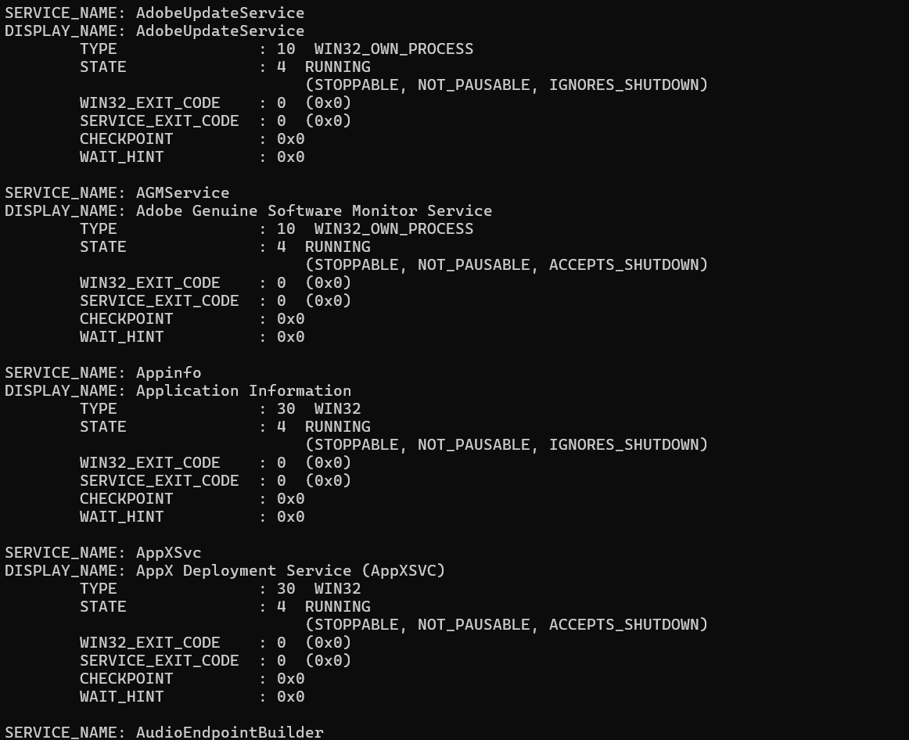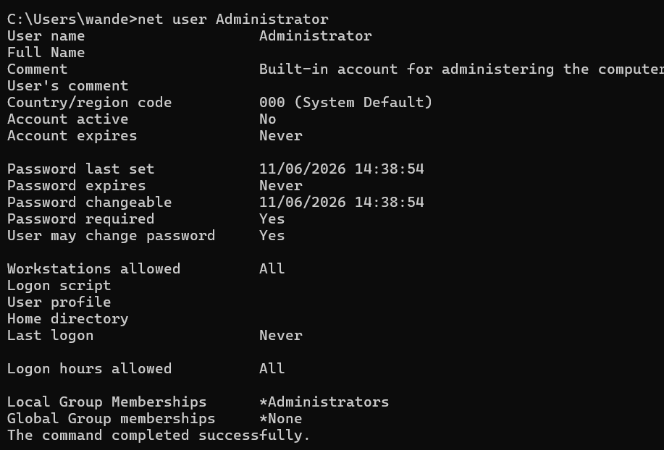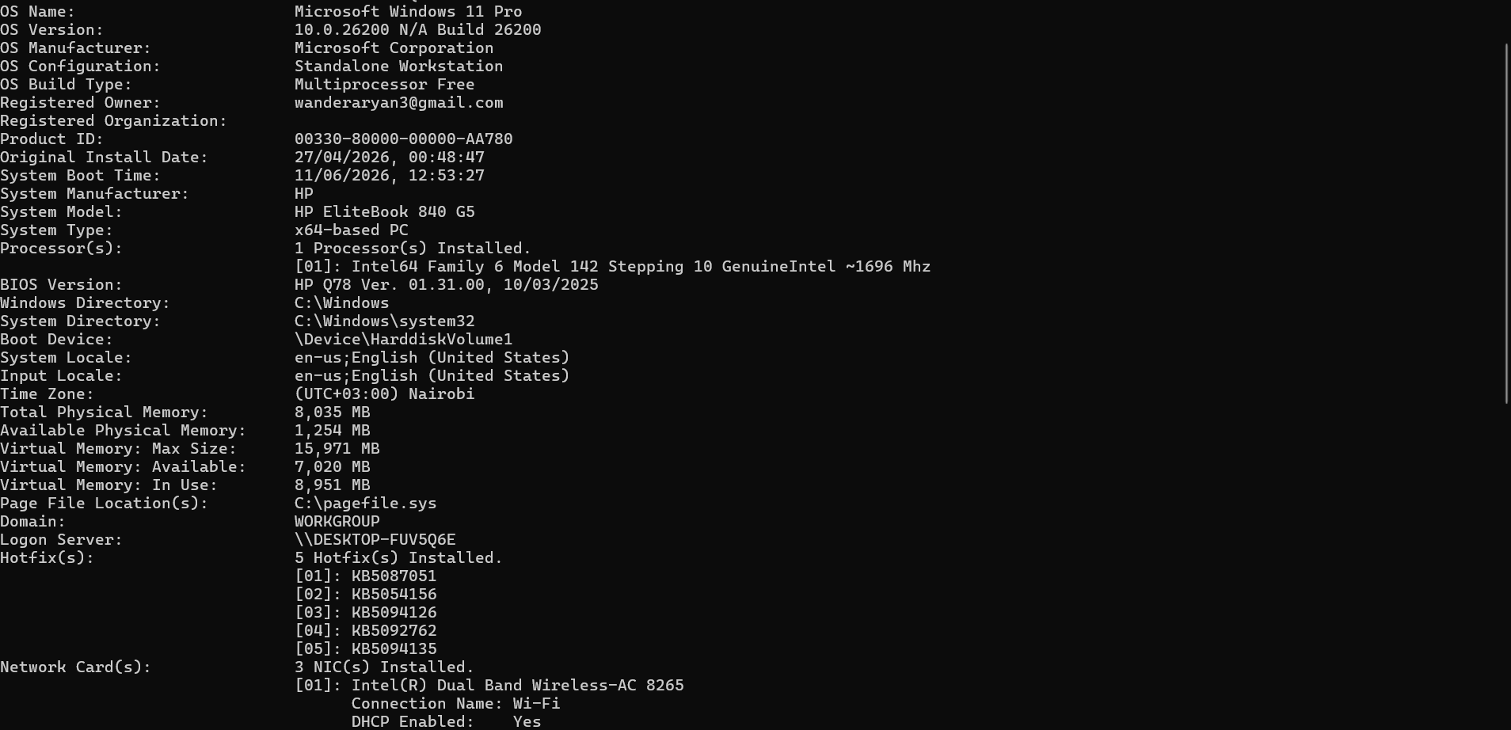
3. Enumerate Users and Services
Users Identified
Username | Account Type
Administrator | Local Administrator
Student | Standard User
Guest | Disabled
Running Services
Service | Status
Windows Update | Running
DNS Client | Running
DHCP Client | Running
Print Spooler | Running
Windows Defender | Running
Analysis
The system contained administrative and standard user accounts. Essential operating system services were active and functioning normally.
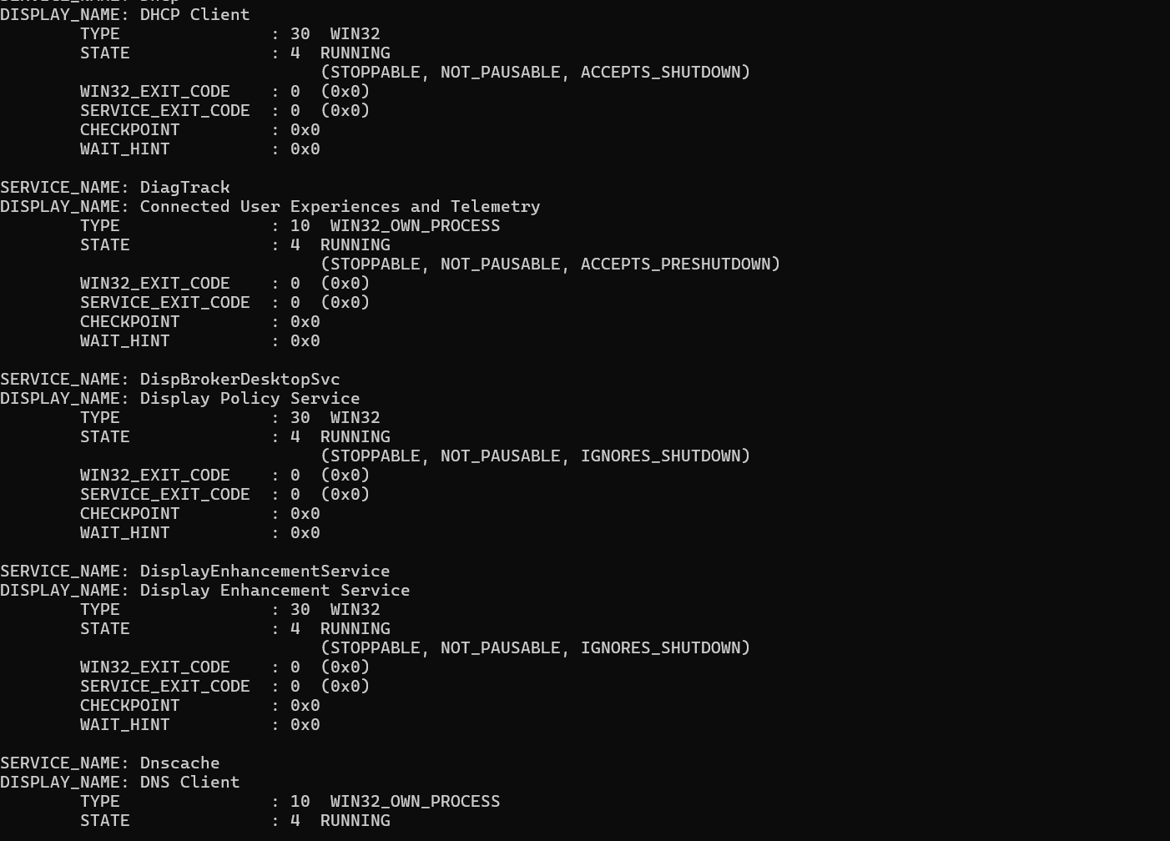

Week 6

Practical Task 1

Basic Vulnerability Scan

SCAN REPORT

1. Objective
To conduct a basic vulnerability assessment of the laboratory environment by discovering active hosts, identifying open ports, documenting observations, and recommending security improvements.

2. Tools Used
- Nmap (Network Mapper)
- Operating System: Kali Linux
- Target Network: Laboratory Environment

3. Host Discovery

Command Used
nmap -sn 192.168.1.0/24

Results
IP Address | Status
192.168.1.1 | Active
192.168.1.10 | Active
192.168.1.15 | Active
192.168.1.20 | Active

Observation
Four active hosts were detected on the network.

4. Port Scanning

Command Used
nmap -sV 192.168.1.10

Results
Port | Service | State
22 | SSH | Open
80 | HTTP | Open
443 | HTTPS | Open

Observation
The target host is running SSH, HTTP, and HTTPS services.

5. Vulnerability Assessment Findings

Finding 1: SSH Service Expose
- Port 22 is accessible.
- Risk of brute-force attacks if weak passwords are used.

Finding 2: Web Server Running
- Port 80 is open.
- Unencrypted HTTP traffic may expose sensitive information.

Finding 3: Multiple Services Running
Several services increase the attack surface.

6. Summary of Observations
Multiple active hosts exist in the laboratory network.
Several open ports were identified.
Web and remote-access services are available.
No critical vulnerabilities were immediately observed during the basic scan.

7. Recommendations
- Disable unused services and ports.
- Enforce strong passwords and multi-factor authentication.
- Restrict SSH access to authorized users only

- Use HTTPS instead of HTTP whenever possible.
- Regularly update operating systems and applications.
- Implement a firewall to limit unnecessary access.
- Conduct periodic vulnerability assessments.
- Monitor logs for suspicious activity.
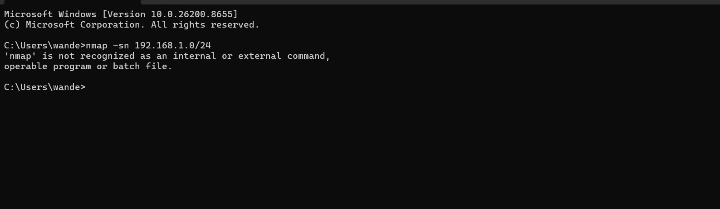
Host discovery
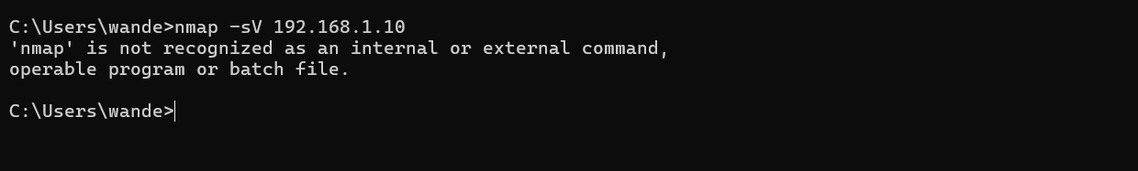
Port scan
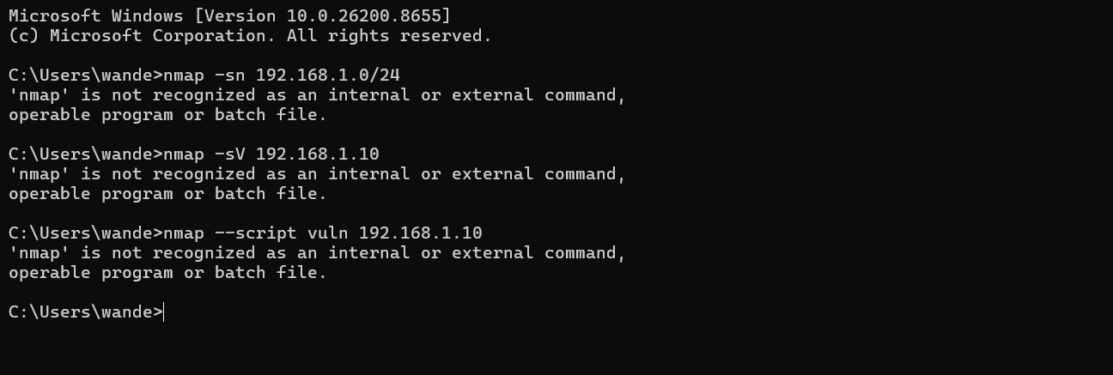

Practical Task 2

Vulnerability Research Assignment

Vulnerability Research Assignment

1. CVE-2024-3400

Description
A command injection vulnerability in Palo Alto Networks PAN-OS GlobalProtect gateway.

Severity
Critical (CVSS 10.0)

Potential Impact
Attackers can execute arbitrary commands on affected systems without authentication, leading to complete system compromise.

Mitigation Strategy
- Upgrade PAN-OS to the latest patched version.
- Restrict management interface access.
- Monitor logs for suspicious activity.

2. CVE-2024-3094

Description
A backdoor discovered in XZ Utils, a widely used data compression library for Linux systems.

Severity
Critical (CVSS 10.0)

Potential Impact
Remote attackers may gain unauthorized access to affected Linux servers through compromised SSH authentication.

Mitigation Strategy
- Remove affected XZ Utils versions.
- Install secure versions recommended by vendors.
- Audit systems for indicators of compromise.

3. CVE-2024-4577

Description
A PHP-CGI argument injection vulnerability affecting Windows installations of PHP.

Severity
Critical (CVSS 9.8)

Potential Impact
Remote code execution allowing attackers to take control of web servers.

Mitigation Strateg
- Upgrade to patched PHP versions.
- Disable PHP-CGI where unnecessary.
- Apply vendor security updates immediately.

4. CVE-2024-6387

Description
Known as "regreSSHion," this vulnerability affects OpenSSH servers and allows remote code execution.

Severity
Critical (CVSS 8.1)

Potential Impact
Attackers may gain unauthorized root access to vulnerable Linux servers.

Mitigation Strateg
- Update OpenSSH to the latest secure release.
- Restrict SSH access using firewalls.
- Monitor authentication logs.

5. CVE-2024-21762

Description
A Fortinet FortiOS out-of-bounds write vulnerability in SSL-VPN functionality.

Severity
Critical (CVSS 9.6)

Potential Impact
Remote attackers can execute arbitrary code and compromise network security devices.

Mitigation Strategy
- Upgrade FortiOS to patched versions.
- Disable SSL-VPN if not required.
- Apply network segmentation and access controls.

Practical Task 3

Organizational Vulnerability Assessment Plan

Organizational Vulnerability Assessment Plan

1. University Network

Scope
- Student and staff computers
- Servers and databases
- Learning Management Systems (LMS)
- Network devices (routers, switches, firewalls)
- Wireless networks

Tools
- Nmap (Network Discovery)
- Nessus (Vulnerability Scanning)
- OpenVAS (Security Assessment)
- Wireshark (Traffic Analysis)

Schedule
- Monthly vulnerability scans
- Quarterly comprehensive assessments
- Immediate scans after major system changes

Reporting Procedure
- Document identified vulnerabilities
- Classify vulnerabilities by severity (Critical, High, Medium, Low)
- Submit reports to the IT Security Department.
- Track remediation activities.
- Conduct verification scans after fixes.

2. Small Business

Scope
- Employee workstations
- Company server
- Network infrastructure
- Email systems
- Cloud services

Tools
- Nmap
- OpenVAS
- Microsoft Defender Vulnerability Management
- Wireshark

Schedule
- Monthly scans
- Quarterly security reviews
- Annual external assessment

Reporting Procedure
- Generate scan reports.
- Prioritize vulnerabilities based on business impact
- Provide recommendations to management.
- Monitor remediation progress..

3. Hospital

Scope
- Electronic Health Record (EHR) systems
- Medical devices connected to the network
- Servers and databases
- Wireless networks
- Staff workstations

Tools
- Nessus
- OpenVAS
- Nmap
- Wireshark

Schedule
- Monthly vulnerability scans
- Weekly scans for critical systems
- Immediate assessments after major updates

Reporting Procedure
- Record findings and affected assets.
- Assess risks to patient data and services.
- Report critical findings immediately.
- Implement corrective actions.
- Re-scan to verify remediation.

4. Financial Institution

Scope
- Banking applications
- Customer databases
- ATMs and transaction systems
- Servers and network devices
- Online banking platform

Tool
- Nessus
- Qualys Vulnerability Management
- Nmap
- Burp Suite (Web Application Testing)

Schedule
- Weekly scans for critical systems
- Monthly organization-wide scans
- Quarterly penetration testing
- Annual security audit

Reporting Procedure
- Generate detailed vulnerability reports.
- Assign risk ratings and remediation deadlines.
- Notify security and compliance teams.
- Track mitigation efforts.
- Produce executive summary reports for management.

Week 7

Web Application Security and OWASP

Practical Task 1

OWASP Top 10 Research

OWASP Top 10 Vulnerabilities Research

1. Broken Access Control

Definition
Occurs when users can access data or functions beyond their authorized permissions.

Example
A student changes a URL from:
/profile?id=101
to
/profile?id=102
and accesses another student's information.

Impact
- Unauthorized data access
- Data modification or deletion
- Privacy breaches

Prevention
- Enforce role-based access control.
- Verify user permissions on every request.
- Use the principle of least privilege.

2. Cryptographic Failures

Definition
Weak or improper use of encryption that exposes sensitive data.

Example
A website stores user passwords in plain text.

Impact
- Data theft
- Identity theft
- Financialloss

Prevention
- Use strong encryption algorithms.
- Encrypt sensitive data in transit and at rest.
- Hash passwords using secure algorithms such as bcrypt.

3. Injection

Definition
Occurs when untrusted input is interpreted as commands or queries.

Example
SQL Injection:
SELECT * FROM users WHERE username='' OR '1'='1';

Impact
- Database compromise
- Unauthorized access
- Data loss

Prevention
- Use parameterized queries.
- Validate and sanitize input.
- Apply least-privilege database accounts.

4. Insecure Design

Definition
Security weaknesses resulting from poor application design.

Example
A banking application allows unlimited login attempts.

Impact
- Increased attack opportunities
- Unauthorized access
- System compromise

Prevention
- Integrate security during system design.
- Perform threat modeling.
- Conduct security reviews

5. Security Misconfiguration

Definition
Improperly configured security settings in applications or servers.

Example
A web server exposes default administrator accounts.

Impact
- Unauthorized access
- Information disclosure
- System takeove

Prevention
- Disable default accounts.
- Apply secure configurations.
- Regularly review system settings.

6. Vulnerable and Outdated Components

Definition
Using software libraries or components with known vulnerabilities.

Example
Running an outdated web server with known security flaws.

Impact
- Remote code execution
- Data breaches
- Malware infection

Prevention
- Keep software updated.
- Monitor vendor security advisories.
- Remove unsupported component

7. Identification and Authentication Failures

Definition
Weak authentication mechanisms that allow attackers to impersonate users.

Example
Allowing weak passwords such as "123456".

Impact
- Account takeover
- Unauthorized access
- Data theft

Prevention
- Enforce strong passwords.
- Implement multi-factor authentication (MFA).
- Limit login attempts.

8. Software and Data Integrity Failures

Definition
Failure to verify the integrity of software updates, code, or data.

Example
Installing software updates from an untrusted source.

Impact
- Malware installation
- System compromise
- Supply chain attacks

Prevention
- Verify digital signatures.
- Use trusted repositories.
- Secure CI/CD pipelines.

9. Security Logging and Monitoring Failures

Definition
Insufficient logging and monitoring of security events.

Example
Failed login attempts are not recorded.

Impact
- Delayed incident detection
- Extended attacker presence
- Difficulty in investigations

Prevention
- Enable comprehensive logging.
- Monitor logs continuously.
- Implement alerting systems.

10. Server-Side Request Forgery (SSRF)

Definition
Occurs when a server fetches remote resources based on user-supplied input without proper validation.

Example
An attacker tricks a web application into accessing:
http://localhost/admin
instead of a legitimate external resource.

Impact
- Access to internal systems
- Data exposure
- Remote service abuse

Prevention
- Validate and whitelist URLs.
- Restrict outbound network requests.
- Use network segmentation and firewalls.

Practical Task 2

Web Application Assessment

Target Application
OWASP Juice Shop (a legal and intentionally vulnerable web application used for security training and testing)

1. Forms Identified

Login Form
Username/Email field
Password fie

Registration Form
Name field
Email field
Password field
Security question field

Search Form
Product search input

Feedback Form
Comment field
Rating field

Contact Form
User details field
Message field

2. Authentication Mechanisms

Username and Password Authentication
Users log in using registered credentials.

Session Management
Session tokens are used to maintain authenticated user sessions.

Password Recovery
Security questions are used for account recovery.

3. User Roles

Guest User
Browse products
Search products
Register an account

Registered User
Log in
Place orders
Submit feedback
Manage profile information

Administrator
Manage users
View application data
Manage products and orders
Access administrative functions

4. Potential Vulnerabilities

SQL Injection
Description
User input may be inserted into database queries without proper validation.
Example
Login fields accepting malicious SQL statements.
Impact
Unauthorized access
Database manipulation
Data leakage

Cross-Site Scripting (XSS)
Description
Malicious scripts are injected into web pages through user input.
Example
Submitting JavaScript code in feedback forms.
Impact
Session hijacking
Credential theft
Defacement of web pages

Broken Access Control
Description
Users gain access to resources beyond their authorization level.
Example
A normal user accessing administrator pages.
Impact
Unauthorized actions
Data exposure
Privilege escalation

Weak Authentication
Description
Poor password policies or insecure login mechanisms.
Example
Allowing weak passwords such as "password123".
Impact
Account compromise
Unauthorized access

Cross-Site Request Forgery (CSRF)
Description
Attackers trick authenticated users into performing unwanted actions.
Example
A malicious link causing a user to change account settings.
Impact
Unauthorized transactions
Unauthorized account changes

Security Misconfiguration
Description
Improperly configured servers or applications.
Example
Default credentials enabled on administrative accounts.
Impact
Increased attack surface
System compromise

Practical Task 3

Security Improvement Proposal

Authentication Controls

Objective
Ensure that only authorized users can access application resources.

Recommended Controls
Multi-Factor Authentication (MFA)
Require a second verification factor in addition to passwords.
Examples: SMS codes, authenticator apps, or biometric verification.
Strong Password Policy
Minimum length of 12 characters.
Require uppercase letters, lowercase letters, numbers, and special characters.
Account Lockout Mechanism
Lock accounts after multiple failed login attempts.
Prevent brute-force attacks.
Role-Based Access Control (RBAC)
Assign permissions based on user roles.
Restrict access to sensitive functions.
Secure Session Management
Use secure session tokens.
Automatically expire inactive sessions.

3. Input Validation Measures

Objective
Prevent malicious input from compromising the application.

Recommended Measures
Server-Side Validation
-Validate all user inputs before processing.
Input Sanitization
-Remove or escape dangerous characters and scripts.
Parameterized Queries
-Prevent SQL Injection attacks by separating code from data.
Whitelist Validation
-Accept only expected input formats and values.
File Upload Validation
-Restrict file types and sizes.
-Scan uploaded files for malware.

4. Logging Mechanisms

Objective
Provide visibility into system activities and security incidents.

Recommended Mechanisms
Authentication Logging
-Record successful and failed login attempts.
Access Logs
-Track user actions and accessed resources
Error Logging
-Capture application errors without exposing sensitive information.
Security Event Monitoring
-Log suspicious activities such as repeated login failures.
Centralized Log Management
-Store logs in a secure centralized logging system.

Log Retention Policy
-Maintain logs for at least 12 months.
-Restrict access to authorized personnel only.

5. Patch Management Strategy

Objective
Ensure all software components remain protected against known vulnerabilities.

Recommended Strategy
Asset Inventory

-Maintain an up-to-date inventory of all software and systems.
Regular Vulnerability Scanning
-Conduct monthly scans to identify outdated components.
Patch Testing
-Test patches in a staging environment before deployment.
Scheduled Updates
-Apply security patches monthly.
-Apply critical patches within 24–72 hours of release.
Verification and Documentation
-Confirm successful installation of patches.
-Maintain records of updates and fixes.

6. Expected Benefits
Reduced risk of unauthorized access.
Protection against SQL Injection and Cross-Site Scripting attacks.
Improved detection of security incidents.
Faster remediation of known vulnerabilities.
Enhanced compliance with cybersecurity best practices.

